Design Overview for <<Grimoire Of The Ancients>>

Name: Jason Pangestu

Student ID: 104404033

Summary of Program
Grimoire of the Ancients is a 2D turn-based magical duel game where two players face off using curated spellbooks containing offensive, and utility spells. Each player will start with a fate decider to decide who will have the turn first to ensure fairness and a fixed amount of health. Each player sets a deck of spells before the battle begins such as lightning, fireball, heal and poison. Fireball and Lightning include unique passive effects that might increase the chance of winning. On each turn a player will select the spell from the spellbook to be cast on the opponent, except for utility spell. The duel continues until one player’s health reaches zero or the timer runs out.

The key to victory on this game relies on player’s tactical choice and timing such as health management, and the combination of spells that was brought to the duel. Good decision can lead to opportunities for comebacks and counterplay in losing situations. The battle is a blend of planning, prediction and strategy. There will also be a random match modifier on every match that increase the difficulty or might increase winning probability. The player will be able to select wizard and grind for level to unlock more wizards and save/load their profile with their desired username and track their statistics.
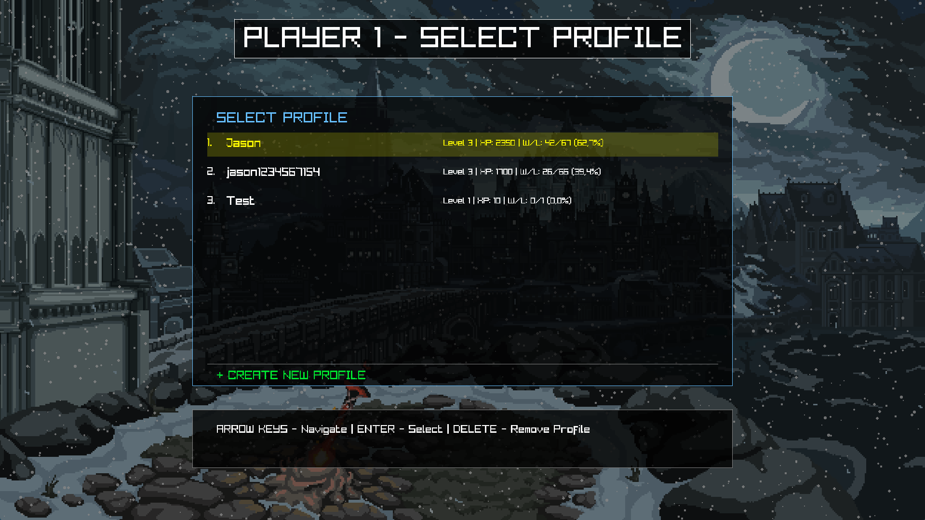

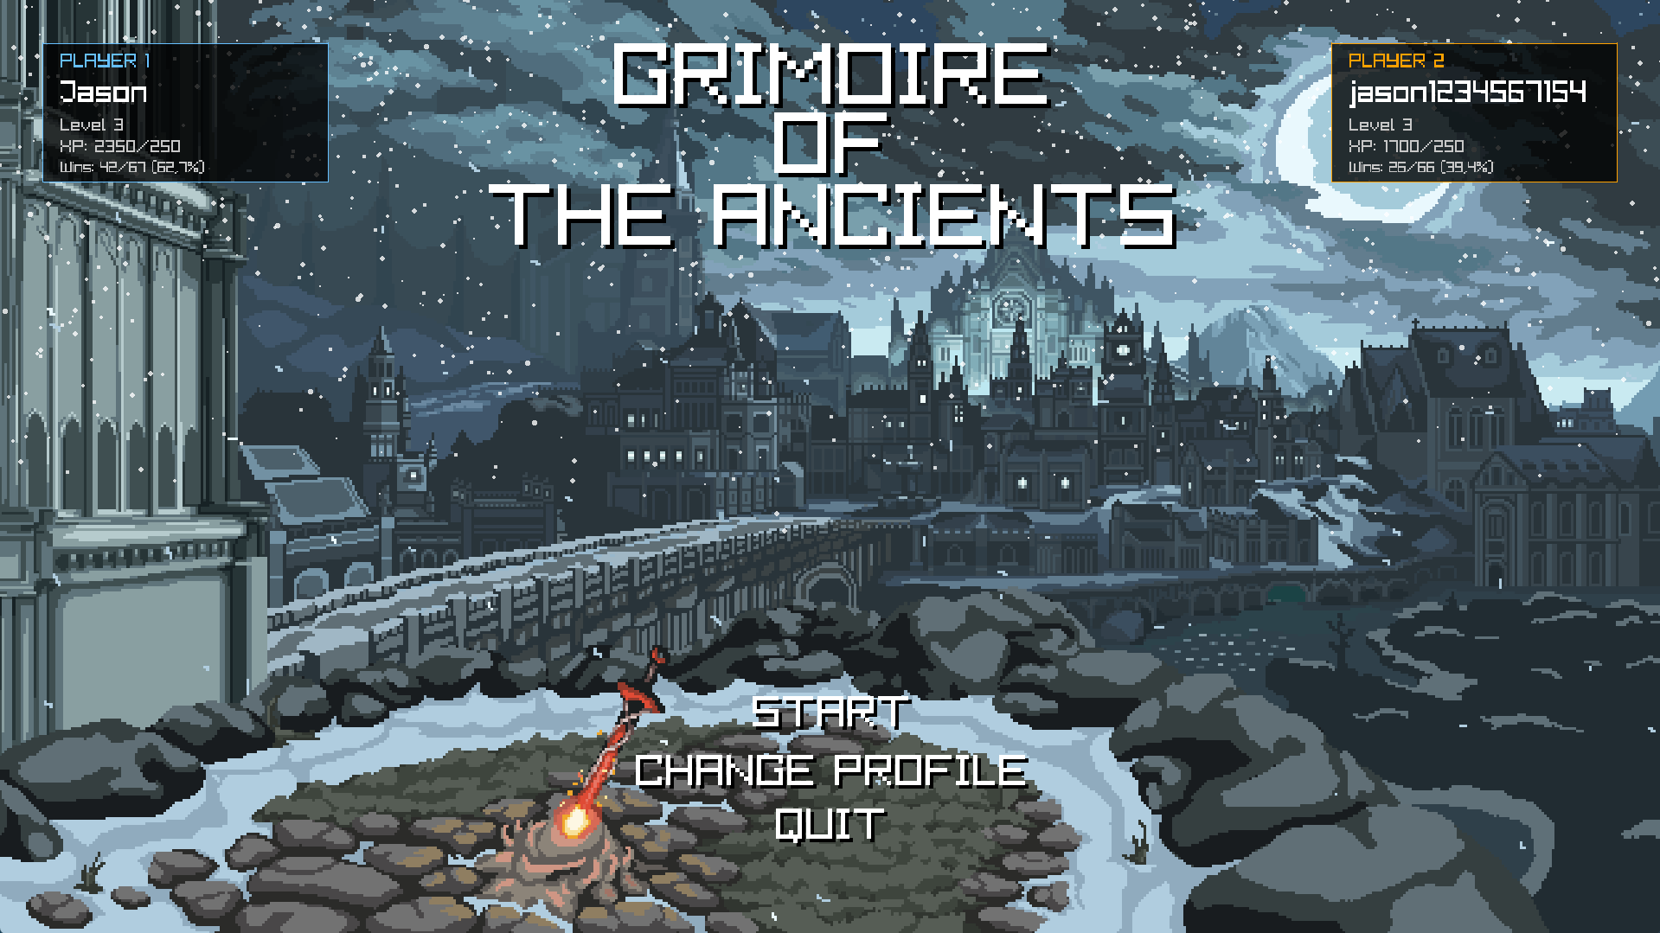
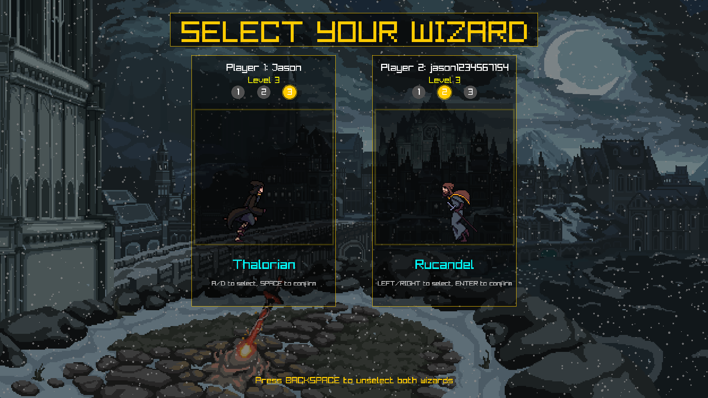
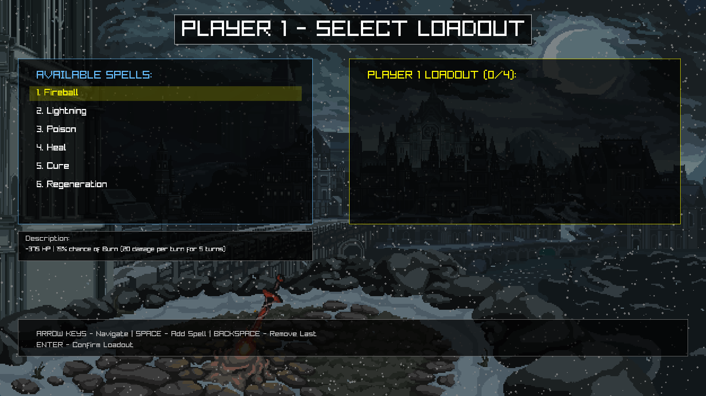
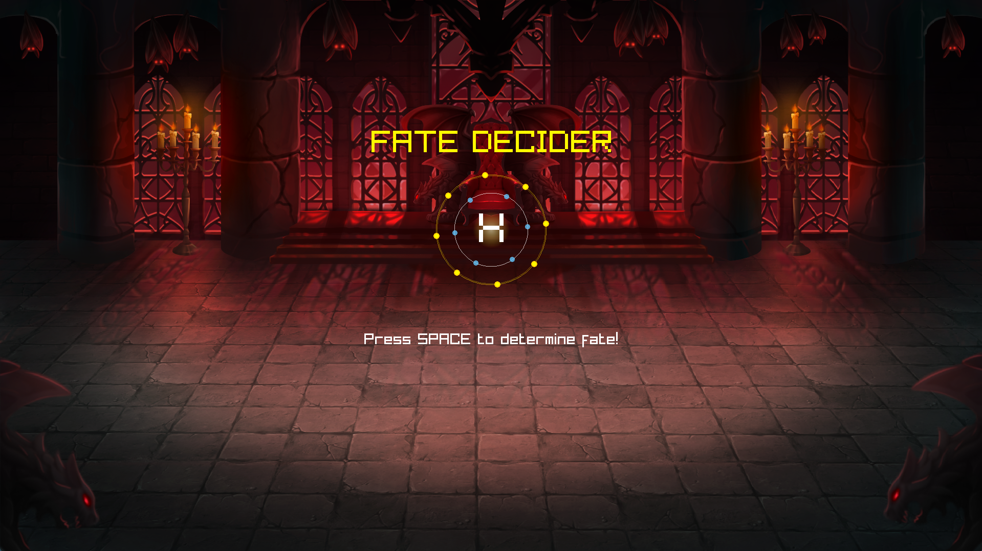
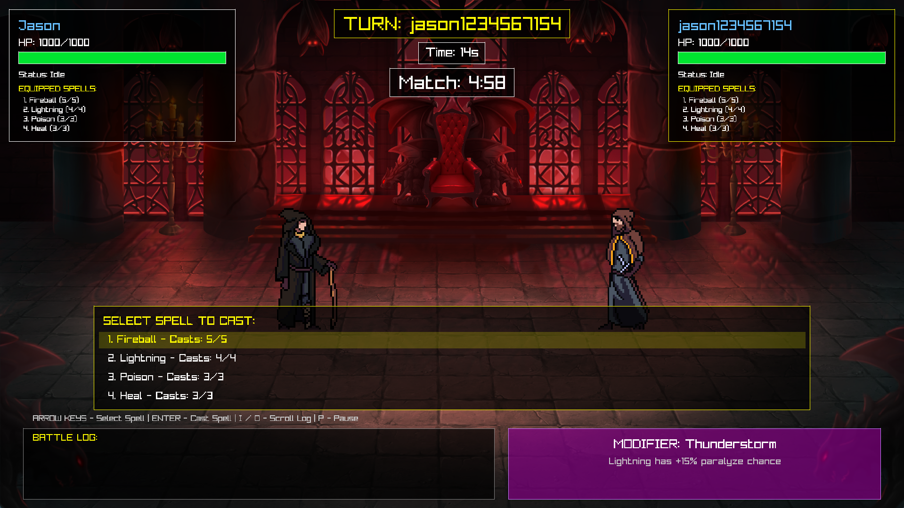
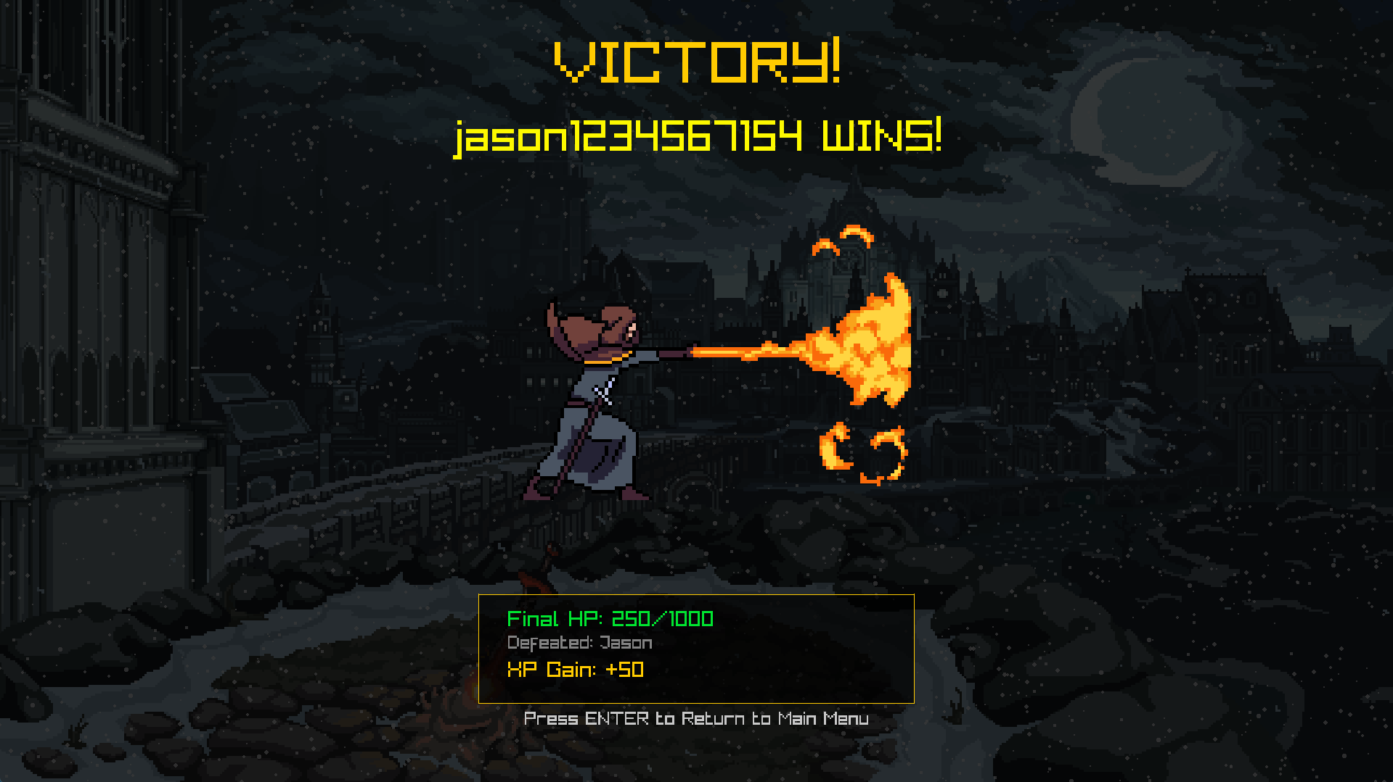

Required Roles

Describe each of the classes, interfaces, and any enumerations you will create. Use a different table to describe each role you will have, using the following table templates.
Table 1: <<GameManager>> details – duplicate
Responsibility | Type Details | Notes
Manage UI | UIManager _uIManager | To access UI logic
Store Modifier | BattleModifier _battleModifier | To access modifier logic
Store coin flip | CoinFlipManager _coinFlipManager | Store coin flip data
Store game state | GameState _state | Current game state
Player 1 Data | Player _player1 | Player 1
Player 2 Data | Player _player2 | Player 2
Player 1 Spellbook data | Spellbook _player1Spellbook | Player 1's spellbook
Player 2 Spellbook data | Spellbook _player2Spellbook | Player 2's spellbook
System Initialization | GameManager static Initialize() | Initialize UI and game mechanics
Update game | void ChangeState(GameState state) | Switches between screens
Transfers spells from spellbooks to players at the start of battle. | void TransferSpellsToPlayers() | Transfers spells from spellbooks to players
Draw game state | Void Draw() | Draw according to the correct game state

Table 2: <<UIManager>> details – duplicate
Responsibility | Type Details | Notes
Store battle modifier | BattleModifier _battleModifier | Global battle modifier affecting game rules
Store particle manager | articleManager _particleManager | Shared particle system for all screens
Store animation system | Animation _animation | Shared sprite and animation utilities
Store audio manager | AudioManager _audioManager | Shared sound and music system
Store battle log | BattleLog _battleLog | Combat message history
Store profile screen | ProfileScreen _profileScreen | Profile selection UI
Store main menu screen | MainMenuScreen _mainMenuScreen | Main menu UI
Store wizards select screen | WizardSelectScreen _wizardSelectScreen | Wizard Select UI
Store loadout screen | LoadoutScreen _loadoutScreen | Spell select UI
Store coin flip screen | CoinFlipScreen _coinFlipScreen | Fate Decider UI
Store end screen | EndScreen _endScreen | End Screen UI
Store battle screen | BattleScreen _battleScreen | Battle UI
Update profile screen | Void UpdateProfileScreen(GameManager gameManager) | Profile screen input
Draw profile screen | void DrawProfileScreen() | Render profile screen UI
Get player 1 profile | PlayerProfile? GetPlayer1Profile() | Get player 1 data
Get player 2 profile | PlayerProfile? GetPlayer2Profile() | Get player 2 data
Save game result | Void SaveGameResult(Player winner, Player loser) | Update player stats
Update main menu | void UpdateMainMenu(GameManager gameManager) | Main menu input
Draw main menu | void DrawMainMenu() | Render main menu UI
Update coin flip screen | void UpdateCoinFlipScreen(GameManager gameManager) | Fate decider input
Reset coin flip screen | void ResetCoinFlipScreen() | Reset fate decider screen
Draw coin flip screen | void DrawCoinFlipScreen() | Render fate decider UI
Update wizard select | void UpdateWizardSelectScreen(GameManager gameManager) | Wizard selection input
Draw wizard select | void DrawWizardSelectScreen() | Render wizard selection UI
Initialize wizard select | void InitializeWizardSelectScreen(PlayerProfile player1Profile, PlayerProfile player2Profile) | Set up wizard selection UI
Update loadout screen | void UpdateLoadoutScreen(GameManager) | Spell loadout input
Draw loadout screen | void DrawLoadoutScreen() | Spell loadout UI
Initialize spellbooks | void InitializeSpellbooks(Spellbook player1Spellbook, Spellbook player2Spellbook) | Spell loadout initialization
Update battle screen | void UpdateBattleScreen(GameManager gameManager, Player player1, Player player2) | Battle screen input
Draw battle screen | void DrawBattleScreen(Player player1, Player player2, BattleModifier modifier  ) | Render battle screen UI
Reset battle screen | void ResetBattleScreen() | Clear battle screen for new game
Update end screen | void UpdateEndScreen(GameManager gameManager) | End screen input
Draw end screen | void DrawEndScreen() | Render end screen UI
Set end screen winner | void SetEndScreenWinner(Player winner, Player loser) | End screen with winner
Set end screen draw | void SetEndScreenDraw(Player player1, Player player2) | End screen for draw

Table 3: <<Animation>> details – duplicate
Responsibility | Type Details | Notes
Store menu background | Texture2D _menuBackground | Menu background
Store battle background | Texture2D _battleBackground | Background for battle
Store wizard frame width | int _wizardFrameWidth | Width of wizard sprite
Store wizard frame height | int _wizardFrameHeight | Height of wizard sprite
Store frames per row | int _wizardFramesPerRow | Number of frames on each sprite
Store win animation frames | int _wizardWinFrames | Frame for winning animation
Store frame speed | float _wizardFrameSpeed | Frame duration in seconds
Store idle sprites | Dictionary<int, Texture2D> _wizardIdleSprites | Idle animation
Store run sprites | Dictionary<int, Texture2D> _wizardRunSprites | Run animation
Store hurt sprites | Dictionary<int, Texture2D> _wizardHurtSprites | Hurt animation
Store dead sprites | Dictionary<int, Texture2D> _wizardDeadSprites | Dead animation
Store win sprites | Dictionary<int, Texture2D> _wizardWinSprites | Win animation
Store cast sprites | Dictionary<int, Texture2D> _castingSprites | Spell casting animation
Store projectile sprites | Dictionary<int, Texture2D> _projectileSprites | Projectile animation
Load all assets | void LoadAllAssets() | Load all textures
Unload all assets | void UnloadAllAssets() | Unload all textures
Get sprite by condition | Texture2D GetWizardSpriteByCondition(CharCondition condition, int wizardId = 0) | Return correct sprite based on condition
Get win sprite | Texture2D GetWizardWinSprite(int wizardId = 0) | Return victory sprite
Get run sprite | Texture2D GetWizardRunSprite(int wizardId = 0) | Return running sprite
Get death frame count | int GetDeathFrameCount(int wizardId) | Return death animation frame
Get charge frame count | int GetChargeFrameCount(int wizardId) | Return charge animation frame
Get background for state | Texture2D GetBackgroundForState(GameState state) | Return background depending on game state
Create spell animation | SpellAnimation CreateSpellAnimation(int wizardId = 0) | Create new spell animation with casting and projectile sprites

Table 4: <<AudioManager>> details – duplicate
Responsibility | Type Details | Notes
Store menu music | Music _menuMusic | BGM for Menu
Store battle music | Music _battleMusic | BGM for battle
Store key sound | Sound _keySound | Navigation sound
Store select sound | Sound _selectSound | Confirmation sound
Store back sound | Sound _backSound | Cancel sound
Store cast sound | Sound _castSound | Spell casting sound
Store fireball sound | Sound _fireballSound | Fireball impact sound
Store lightning sound | Sound _lightningSound | Lightning impact sound
Store poison sound | Sound _poisonSound | Poison impact sound
Store cure sound | Sound _cureSound | Cure casting sound
Store heal sound | Sound _healSound | Heal and regen casting sound
Load audios | void LoadAllAudio() | Loads musics and SFXs
Unload audios | void UnloadAudio() | Unload music and SFXs
Update music stream | void UpdateMusicStream() | Update music buffer
Play menu music | void PlayMenuMusic() | Start menu BGM
Stop menu music | void StopMenuMusic() | Stop menu BGM
Play battle music | void PlayBattleMusic() | Start battle BGM
Stop battle music | void StopBattleMusic() | Stop battle BGM
Play key sound | void PlayKeySound() | Start navigation sound
Play select sound | void PlaySelectSound() | Start confirmation sound
Play back sound | void PlayBackSound() | Start cancel sound
Play cast sound | void PlayCastSound() | Start spell casting sound
Play fireball sound | void PlayFireballSound() | Start fireball impact sound
Play lightning sound | void PlayLightningSound() | Start lightning impact sound
Play poison sound | void PlayPoisonSound() | Start poison impact sound
Play cure sound | void PlayCureSound() | Start cure casting sound
Play heal sound | void PlayHealSound() | Start heal and regen casting sound

Table 5: <BattleLog>> details – duplicate
Responsibility | Type Details | Notes
Store messages | List<string> _messages | List of messages in battle log
Store max messages | int _maxMessages | Maximum messages in battle log
Store scroll offset | int _scrollOffset | Current scroll position
Store visible lines | int _visibleLines | Number of lines displayed at once
Store message counter | int _messageCounter | Sequential message numbering
Add message | void AddMessage(string message) | Add messages into the list
Clear messages | void Clear() | Remove all messages
Scroll up | void ScrollUp() | Move up battle log by one line
Scroll down | void ScrollDown() | Move down battle log by one line
Draw battle log | void Draw(int x, int y, int width, int height, int fontSize) | Render battle log UI
Get message color | public Color GetMessageColor(string message) | Assign color based on special cases

Table 6: <<BattleModifier>> details – duplicate
Responsibility | Type Details | Notes
Store modifier type | ModifierType _type | Type of battle modifier
Store description | string _description | Description of battle modifier
Apply modifier | void Apply() | Set description based on modifier type

Table 7: <<BattleScreen>> details – duplicate
Responsibility | Type Details | Notes
Store particle manager | ParticleManager _particleManager | For particle effect
Store animation system | Animation _animation | For animation effect
Store audio manager | AudioManager _audioManager | For audio and music
Store battle log | BattleLog _battleLog | For combat log
Store coin flip screen | CoinFlipScreen _coinFlipScreen | To check who will cast first
Store current turn | int _currentTurn | Active player (1 or 2)
Store selected spell index | int _selectedBattleSpellIndex | Index of selected spell UI
Store animation time | float _battleAnimationTime | Time for blinking effect
Store current frame | int _currentFrame | Current frame for wizard sprite
Store frame counter | float _frameCounter | Timer to continue animation friends
Store casting player | int _castingPlayer | Check which player is currently casting (1 or 2)
Store damage applied flag | bool _spellDamageApplied | Ensure damage apply
Store spell animation | SpellAnimation? _currentSpellAnimation | Active projectile animation
Store pending spell | Spell? _pendingSpell | Spell damage to apply when spell hits
Store pending caster | Player? _pendingCaster | Caster saved for deferred application
Store pending target | Player? _pendingTarget | Target saved for deferred application
Store turn timer | float _turnTimer | Remaining seconds for current turn
Store match timer | float _matchTimer | Remaining seconds for entire match
Store turn time limit | float _turnTimeLimit | Default turn duration
Store skips paralyze check | bool _skipNextParalyzeCheck | Allow caster to have extra turn when enemy paralyzed
Stores paralyze display timer | float _paralyzeDisplayTimer | Duration to show paralyzed status
Store paralyze display duration | float _paralyzeDisplayDuration | Duration display time for paralyze
Store player 1 death frame | int _player1DeathFrame | Death animation frame for player 1
Store player 2 death frame | int _player2DeathFrame | Death animation frame for player 2
Store pause flag | bool _isPaused | Determine whether battle is paused
Reset battle | void ResetBattle() | Reset battle for new game
Update battle | void Update(GameManager gameManager, Player player1, Player player2, BattleModifier battleModifier) | Process input for game manager, timer, animation and turn
Draw battle screen | void Draw(Player player1, Player player2, BattleModifier modifier) | Render battle UI
Draw player stats | void DrawPlayerStats(Player player, int x, int y, bool isActive) | Rendel Player UI such as HP, name, wizard
Draw spell selection | void DrawSpellSelection(Player player, int x, int y) | Rendel spell list with highlight if selected

Table 8: <<BMRandomizer>> details – duplicate
Responsibility | Type Details | Notes
Store modifier pool | List<ModifierType> _modifierPool | Available battle modifiers
Store randomizer | Random _randomizer | Random number generator instance
Get random modifier | ModifierType GetRandomModifier() | Returns random modifier from pool

Table 9: <<BurnEffect>> details – duplicate
Responsibility | Type Details | Notes
Initialize burn effect | void override Apply(Player target, Player caster, BattleLog? battleLog) | Creates burn with damage per turn and duration

Table 10: <<CoinFlipManager>> details – duplicate
Responsibility | Type Details | Notes
Store player choice | CoinSide _playerChoice | Player choice heads or tails (1 / 2)
Store flip result | CoinSide _result | Result of fate decider
Flip coin | CoinSide Flip() | Generate heads or Tails and store result randomly
Check player result | bool PlayerChoiceResult() | Return true if player’s choice are the same as the result

Table 11: <<CoinFlipScreen>> details – duplicate
Responsibility | Type Details | Notes
Store coin flipped flag | bool _coinFlipped | Check if coin has been flipped
Store flip timer | float _coinFlipTimer | Time before proceeding to battle screen
Store flip message | string _coinFlipMessage | Return message showing who goes first
Store battle started flag | bool _battleStarted | Check if battle has begun
Store first turns | int _firstTurn | Assign which player will go first (1 or 2)
Store rotation | float _coinFlipRotation | Rotation for magical circle
Store pulse timer | float _coinFlipPulse | Timer for pulse animation
Reset screen | void Reset() | Clears all state for new coin flip
Update screen | void Update(GameManager gameManager) | Process all inputs, animations, logic and transition
Draw screen | void Draw() | Render all UI for fate decider

Table 12: <<Cure>> details – duplicate
Responsibility | Type Details | Notes
Cast Cure | void override Cast(Player caster, Player target) | Remove all negative effect from caster

Table 13: <<Effect>> details – duplicate
Responsibility | Type Details | Notes
Store tick value | int _tickValue | Damage or heal per turn
Store duration | int _duration | Duration per turn
Decrement duration | void DecrementDuration() | Reduce duration 1 turn
Check for effect expiry | bool IsExpired() | Return true is expired if duration is less or equal to 0
Apply effect | abstract void Apply(Player target, Player caster, BattleLog? battleLog); | Must be implemented by child classes

Table 14: <<EndScreen>> details – duplicate
Responsibility | Type Details | Notes
Store animation system | Animation _animation | Animation system
Store particle manager | ParticleManager _particleManager | Particle System
Store winner | Player? _winner | Winner player
Store loser | Player? _loser | Loser player
Check whether its draw | bool _isDraw | Whether game ended in draw
Store player 1 XP Gain | int _player1XPGain | 50 XP for winning and 10 for losing, also 10 xp for both if draw
Store player 2 XP Gain | int _player2XPGain | 50 XP for winning and 10 for losing, also 10 xp for both if draw
Store current frame | int _currentFrame | Current wizard sprite frame
Store frame counter | float _frameCounter | Timer for frame switch
Set Winner screen | void SetWinner(Player winner, Player loser) | Set end screen if one of the player wins
Set Draw screen | void SetDraw(Player player1, Player player2) | Set end screen if draw
Update screen | void Update(GameManager gameManager) | Process input and animations
Draw screen | void Draw() | Render particles, title and UI

Table 15: <<Fireball>> details – duplicate
Responsibility | Type Details | Notes
Random chance | Random _random; | Random number generator for effect chance
Cast fireball spell | override void Cast(Player caster, Player target) | Casts the Fireball spell, dealing damage and potentially applying Burn effect

Table 16: <<Heal>> details – duplicate
Responsibility | Type Details | Notes
Cast Heal spell | override void Cast(Player caster, Player target) | Casts the Heal spell, restoring health to the caster.

Table 17: <<HealingParticle>> details – duplicate
Responsibility | Type Details | Notes
Store lifetime | float _lifetime | Current lifetime of the particle
Store max lifetime | float _maxLifetime | Maximum lifetime of the particle
Store size | float _size | Size of the particle
Store alpha | float _alpha | Transparency of the particle
Store color | Color _color | Color of the particle
Store position | Vector2 _position | Current position of the particle
Store velocity | Vector2 _velocity | Velocity of the particle
Update particle | void Update(float deltaTime) | Updates the particle's position and lifetime.
Draw particle | void Draw() | Draws the particle on the screen.
Check if expired | bool IsExpired() | Determines if the particle's lifetime has expired.

Table 18: <<Lightning>> details – duplicate
Responsibility | Type Details | Notes
Random number for chance | Random _random | Random number generator for effect chance
Cast lightning spell | override void Cast(Player caster, Player target) | Casts the Lightning spell, dealing damage and potentially applying Paralyze effect

Table 19: <<LoadoutScreen>> details – duplicate
Responsibility | Type Details | Notes
Store current player | int _currentPlayer | Which player is currently selecting (1 or 2)
Store selected spell index | int _selectedSpellIndex | Index of the currently highlighted spell in the available list
Store player 1 spellbook | Spellbook? _player1Spellbook | Player 1's spellbook (nullable until Initialize is called)
Store player 2 spellbook | Spellbook? _player2Spellbook | Player 2's spellbook (nullable until Initialize is called)
Store particle manager | ParticleManager _particleManager | Particle manager used for background visual effects
Store audio manager | AudioManager _audioManager | Audio manager used for UI sound effects
Initialize screen | void Initialize(Spellbook player1Spellbook, Spellbook player2Spellbook) | Initializes the loadout screen with the players' spellbooks.
Update screen | void Update(GameManager gameManager) | Updates the loadout screen based on player input.
Draw screen | void Draw() | Renders background particles, available spells, descriptions, and current loadout.

Table 20: <<MainMenuScreen>> details – duplicate
Responsibility | Type Details | Notes
Store title animation time | float _titleAnimationTime | Timer for title animation
Store particle manager | ParticleManager _particleManager | Particle system
Store audio manager | AudioManager _audioManager | Audio system
Update screen | void Update(GameManager gameManager) | Update the main menu logic (input handling and state transitions).
Draw screen | void Draw(PlayerProfile? player1Profile, PlayerProfile? player2Profile) | Draw the main menu UI, including animated title, buttons, and player profiles.

Table 21: <<ParalyzeEffect>> details – duplicate
Responsibility | Type Details | Notes
Apply paralyze | override void Apply(Player target, Player caster, BattleLog? battleLog) | Applies the paralyze effect to the target player.

Table 22: <<ParticleManager>> details – duplicate
Responsibility | Type Details | Notes
Store snow particles | List<Snowflake> _particles | List of snowflake particles
Store healing particles | List<HealingParticle> _healingParticles | List of healing particles
Store random generator | Random _random | Random number generator
Store animation time | float _animationTime | Animation time for particle effects
Store min speed | float _minSpeed | Minimum speed of snowflakes
Store max speed | float _maxSpeed | Maximum speed of snowflakes
Store min size | float _minSize | Minimum size of snowflakes
Store max size | float _maxSize | Maximum size of snowflakes
Initialize particles | void InitializeParticles(int screenWidth, int screenHeight, int particleCount) | Initializes particles with specified count
Update all particles | void Update(float deltaTime, int screenWidth, int screenHeight) | Updates all particles and handles their lifecycle
Update snow only | void UpdateSnow(float deltaTime, int screenWidth, int screenHeight) | Updates only snow particles (for menu/loadout screens)
Update healing only | void UpdateHealing(float deltaTime) | Updates only healing particles (for battle screen)
Draw snow particles | void DrawSnow() | Renders only snow particles (for menu/loadout/end screens)
Draw healing particles | void DrawHealing() | Renders only healing particles (for battle screen)
Spawn healing particles | void SpawnHealingParticles(float x, float y, Color color, int count) | Spawns healing particles around a specific position with a specific color

Table 23: <<Player>> details – duplicate
Responsibility | Type Details | Notes
Store name | string _name | Player's name
Store current HP | int _currentHP | Player's current health points
Store max HP | int _maxHP | Player's maximum health points
Store hit timer | float _hitTimer | Timer to track how long to display Hit status
Store wizard ID | int _selectedWizardId | Selected wizard sprite ID
Store condition | CharCondition _condition | Player's current condition/status
Store active spells | List<Spell> _activeSpells | List of spells the player can cast
Store active effects | List<Effect> _activeEffects | List of active effects on the player
Take damage | void TakeDamage(int value) | Reduces the player's HP by the specified value and updates condition if necessary
Heal | void Heal(int value) | Heals the player by the specified value, not exceeding max HP
Check if alive | bool IsAlive() | Checks if the player is alive (HP > 0)
Set condition | void SetCondition(CharCondition newCondition) | Sets the player's condition/status
Clear condition | void ClearCondition() | Clears the player's condition/status to Idle
Apply effect | void ApplyEffect(Effect effect) | Applies an effect to the player.
Clear all effects | void ClearAllEffects() | Clears all active effects from the player
Process effects | void ProcessEffect(BattleLog? battleLog) | Processes all active effects on the player
Update player | void Update(float deltaTime) | Updates the player's status each frame

Table 24: <<PlayerProfile>> details – duplicate
Responsibility | Type Details | Notes
Store username | string _username | Player's display name
Store level | int _level | Current player level (1..3)
Store XP | int _xp | Total accumulated XP
Store unlocked wizards | List<int> _unlockedWizards | IDs of unlocked wizards
Store selected wizard ID | int _selectedWizardId | Currently selected wizard ID
Store games won | int _gamesWon | Total games won
Store games played | int _gamesPlayed | Total games played
Store level 2 XP | int _xpForLevel2 | XP threshold for level 2
Store level 3 XP | Int _xpForLevel3 | XP threshold for level 3
Add XP | void AddXP(int amount) | Adds XP and triggers level update logic
Update level | void UpdateLevel() | Updates level based on current XP and unlocks wizards when leveling up
Unlock wizards | void UnlockWizardsForLevel(int level) | Adds wizard unlocks tied to specific levels
Record game | void RecordGame(bool won, int xpGained) | Records a game result, increments game counters and awards XP
Get next level XP | int GetXPForNextLevel() | Returns the XP threshold required to reach the next level
Get win rate | float GetWinRate() | Returns win rate percentage (0-100)
To JSON | string ToJson() | Serializes this profile to a JSON string using System.Text.Json.
From JSON | static PlayerProfile? FromJson(string json) | Deserializes a PlayerProfile from JSON. Returns null on error and logs the exception message.
Table 25: <<Poison>> details – duplicate
Responsibility | Type Details | Notes
Cast poison spell | override void Cast(Player caster, Player target) | Casts the Poison spell, dealing damage and applying Poison effect
Cast with modifier | void CastWithModifier(Player caster, Player target, BattleModifier? modifier) | Casts the Poison spell with a battle modifier, dealing damage and applying Poison effect

Table 26: <<PoisonEffect>> details – duplicate
Responsibility | Type Details | Notes
Apply poison damage | override void Apply(Player target, Player caster, BattleLog? battleLog) | Applies the poison effect to the target player

Table 27: <<ProfileManager>> details – duplicate
Responsibility | Type Details | Notes
Store profiles directory path | string _profilesDirectory | Directory to store profiles
Store file extension | string _profileExtension | File extension for profile files
Ensure storage exists | void EnsureProfilesDirectoryExists() | Ensures the profiles directory exists
Save profile to disk | bool SaveProfile(PlayerProfile profile) | Saves a player profile to disk
Load profile from disk | PlayerProfile? LoadProfile(string username) | Loads a player profile from disk
Check profile existence | bool ProfileExists(string username) | Checks if a profile exists
Create new profile | PlayerProfile CreateNewProfile(string username) | Creates a new profile with the given username
List all profiles | List<string> GetAllProfileNames() | Gets a list of all existing profile usernames
Delete profile | bool DeleteProfile(string username) | Deletes a profile
Get safe filename | string GetProfileFilename(string username) | Gets the filename for a profile

Table 28: <<ProfileScreen>> details – duplicate
Responsibility | Type Details | Notes
Store profile manager | ProfileManager _profileManager | Profile manager (load/save/create/delete profiles)
Store particle manager | ParticleManager _particleManager | Particle system for background visuals
Store audio manager | AudioManager _audioManager | Plays key/select/back sounds
Store existing profiles list | List<string> _existingProfiles | Ordered list of all profile names shown in UI
Cache loaded profiles | Dictionary<string, PlayerProfile> _cachedProfiles | Cache of loaded profiles keyed by username
Track selected index | int _selectedProfileIndex | Current selection index
Track creation mode | bool _isCreatingNew | True when user is entering a new profile name
Store new username buffer | string _newUsername | Buffer for typed username during creation
Store username length limit | int _maxUsernameLength | Maximum allowed username length
Track scroll position | int _scrollOffset | Index of first visible profile when scrolling long lists
Track visible limit | int _maxVisibleProfiles | How many profiles to show at once in the list
Track confirmation state | bool _isConfirmingDelete | True when delete confirmation prompt is active
Store profile to delete | string _profileToDelete | Username pending deletion confirmation
Store player 1 profile | PlayerProfile? _player1Profile | Selected profile for Player 1 (nullable)
Store player 2 profile | PlayerProfile? _player2Profile | Selected profile for Player 2 (nullable)
Track current player | int _currentPlayer | Which player is currently selecting a profile (1 or 2)
Refresh profile list | void RefreshProfileList() | Refresh the in-memory list/cache of profiles from persistent storage
Main update entry | void Update(GameManager gameManager) | Main update entrypoint for the screen. Delegates to appropriate input handlers
Handle profile selection | void HandleProfileSelection(GameManager gameManager) | Handle navigation, selection, deletion confirmation and backing out when not creating a new profile
Handle new profile input | void HandleNewProfileInput(GameManager gameManager) | Handle keyboard input while creating a new profile (text entry, confirm, cancel)
Main draw entry | void Draw() | Draws the full profile screen including particles background and either selection or new-profile UI
Draw profile list | void DrawProfileSelection() | Draws the list of existing profiles, handles highlighting and "Create New" entry at bottom
Draw creation input | void DrawNewProfileInput() | Draw UI for entering a new username (text input box, char limit, instructions)
Table 29: <<RegenEffect>> details – duplicate
Responsibility | Type Details | Notes
Apply regeneration | override void Apply(Player target, Player caster, BattleLog? battleLog) | Applies the regeneration effect to the target player

Table 30: <<Regeneration>> details – duplicate
Responsibility | Type Details | Notes
Cast regeneration spell | override void Cast(Player caster, Player target) | Casts the Regeneration spell, applying a regeneration effect to the caster

Table 31: <<Snowflake>> details – duplicate
Responsibility | Type Details | Notes
Store horizontal position | float _x | Horizontal position
Store vertical position | float _y | Vertical position
Store fall speed | float _speed | Fall speed
Store size | float _size | Radius for drawing
Store sway phase offset | float _swayOffset | Phase offset for horizontal sway
Update position | void Update(float animationTime) | Updates the snowflake's position based on speed and sway
Reset position | void Reset(int screenWidth, Random random) | Resets the snowflake to the top with a new random horizontal position
Draw snowflake | void Draw() | Draws the snowflake on the screen
Check off-screen | bool IsOffScreen(int screenHeight) | Checks if the snowflake is off the bottom of the screen
Table 32: <<Spell>> details – duplicate
Responsibility | Type Details | Notes
Store spell name | string _name | Spell name
Store description | string _description | Short description of spell
Store cast limit | int _castLimit | Maximum number of times this spell can be cast before reset
Store remaining casts | int _castRemaining | Remaining casts available
Store effect value | int _effectValue | Numeric strength/value of the spell effect
Store effect chance | float _effectChance | Chance (0.0-1.0) that the effect will occur
Store effect type | SpellEffect _effect | The effect object/enum associated with the spell
Check castability | bool Castable() | Checks if the spell is castable (has remaining casts)
Consume cast | void UseCast() | Uses one cast of the spell, reducing remaining casts by one
Reset casts | void Reset() | Resets the spell's remaining casts to the cast limit
Cast spell | virtual void Cast(Player caster, Player target) | Casts the spell on the target player

Table 33: <<SpellAnimation>> details – duplicate
Responsibility | Type Details | Notes
Store casting sprite | Texture2D _castingSprite | Wizard casting animation (casting sprite)
Store projectile sprite | Texture2D _projectileSprite | Projectile effect (projectile sprite)
Track animation time | float _animationTime | Elapsed animation time (seconds)
Track current frame | int _currentFrame | Current frame index for casting animation
Track frame accumulator | float _frameCounter | Accumulator for frame timing
Store frame speed | float _frameSpeed | Frame duration in seconds (faster frame speed for charge animation)
Store casting frames per row | int _castingFramesPerRow | Number of frames in casting sprite sheet row
Store projectile frames per row | int _projectileFramesPerRow | Number of frames in projectile sprite sheet row
Store casting frame width | int _castingFrameWidth | Width of a single casting frame (pixels)
Store casting frame height | int _castingFrameHeight | Height of a single casting frame (pixels)
Store projectile frame width | int _projectileFrameWidth | Width of a single projectile frame (pixels)
Store projectile frame height | Int _projectileFrameHeight | Height of a single projectile frame (pixels)
Store start position | Vector2 _projectileStart | Projectile start position (caster)
Store end position | Vector2 _projectileEnd | Projectile target position
Store current position | Vector2 _projectilePos | Current projectile position
Track progress | float _projectileProgress | Interpolation progress 0..1 along path
Store duration | float _projectileDuration | Time in seconds for projectile to travel
Track active state | bool _isProjectileActive | Whether projectile is currently active/moving
Track hit state | bool _hasHit | Whether projectile has reached the target
Start animation | void StartAnimation(Vector2 casterPos, Vector2 targetPos) | Starts the spell animation from caster to target positions
Update animation | void Update(float deltaTime) | Updates the spell animation state
Draw casting sprite | void DrawCastingAnimation(Rectangle destRec, Vector2 origin, Color tintColor, bool flipHorizontal) | Draws the casting animation at the specified destination rectangle
Draw projectile | void DrawProjectile(float scale) | Draws the projectile animation at its current position

Table 34: <<Spellbook>> details – duplicate
Responsibility | Type Details | Notes
Store all spells | List<Spell> _spells | All known spells available to the player
Store equipped spells | List<Spell> _spellLoadout | Currently equipped spells (4)
Equip spell | void EquipSpell(Spell spell) | Equips a spell to the loadout if there is space and it's not already equipped
Unequip spell | void UnequipSpell(int slot) | Unequips a spell from the specified loadout slot
Initialize spell collection | void InitializeSpells() | Initializes the spellbook with predefined spells

Table 35: <<WizardSelectScreen>> details – duplicate
Responsibility | Type Details | Notes
Store animation system | Animation _animation | Animation system used to get wizard sprites and frame info
Store particle manager | ParticleManager _particleManager | Manages snow/particle effects on the screen
Store audio manager | AudioManager _audioManager | Plays UI/key/select/back sounds
Store profile manager | ProfileManager _profileManager | Loads/saves player profiles
Store player 1 profile | PlayerProfile? _player1Profile | Currently loaded profile for player 1
Store player 2 profile | PlayerProfile? _player2Profile | Currently loaded profile for player 2
Track player 1 selection | int _player1SelectedIndex | Index into PlayerProfile.UnlockedWizards for player 1
Track player 2 selection | int _player2SelectedIndex | Index into PlayerProfile.UnlockedWizards for player 2
Track player 1 confirmation | bool _player1Confirmed | Whether player 1 has confirmed their selection
Track player 2 confirmation | bool _player2Confirmed | Whether player 2 has confirmed their selection
Track animation time | float _animationTime | Time accumulator used to advance animation frames
Track current frame | int _currentFrame | Current animation frame index for displaying sprites
Store display width | int _wizardDisplayWidth | Width of the wizard display area (pixels)
Store display height | int _wizardDisplayHeight | Height of the wizard display area (pixels)
Set profiles | void Initialize(PlayerProfile player1Profile, PlayerProfile player2Profile) | Initializes the wizard selection screen with the given player profiles
Main update | bool Update(GameManager gameManager) | Updates the wizard selection screen logic
Main draw | void Draw() | Draws the wizard selection screen UI
Draw player selection | void DrawPlayerWizardSelection(PlayerProfile? profile, int selectedIndex, bool confirmed, int baseX, string playerLabel, string controls, bool mirrored) | Draws the wizard selection UI for a single player

Table 36: <<ModifierType>> details
Value | Notes
Toxic Mist | Poison deal +10% damage
Inferno | Fireball have +15% chance to inflict burn
Heal Surge | Healing spell restore +20% more HP
Thunderstorm | Lightning have 15% increased chance to triggers paralyze

Table 37: <<SpellEffect>> details
Value | Notes
Burn | Deal damage over time
Paralyze | Prevents target’s action for 1 turn
Poison | Deal damage over time until cured
Regen | Heals HP over time
Heal | Restore HP instantly
Cure | Remove burn and poison effect

Table 37: <<CharCondition>> details
Value | Notes
Idle | Default, idle state
Hit | Casting spell
Dead | Hp reaches 0
Paralyzed | Turn skipped

Table 38: <<CoinSide>> details
Value | Notes
Heads | Coin Side
Tails | Coin Side

Table 39: <<GameState>> details
Value | Notes
MainMenu | Start menu of the game
ProfileSelect | Player can choose profile to load / create / delete
WizardSelect | Player can choose their desired wizard
LoadoutSelect | Spell selection
Battle | Battle scene
EndScreen | Victory screen

Class Diagram

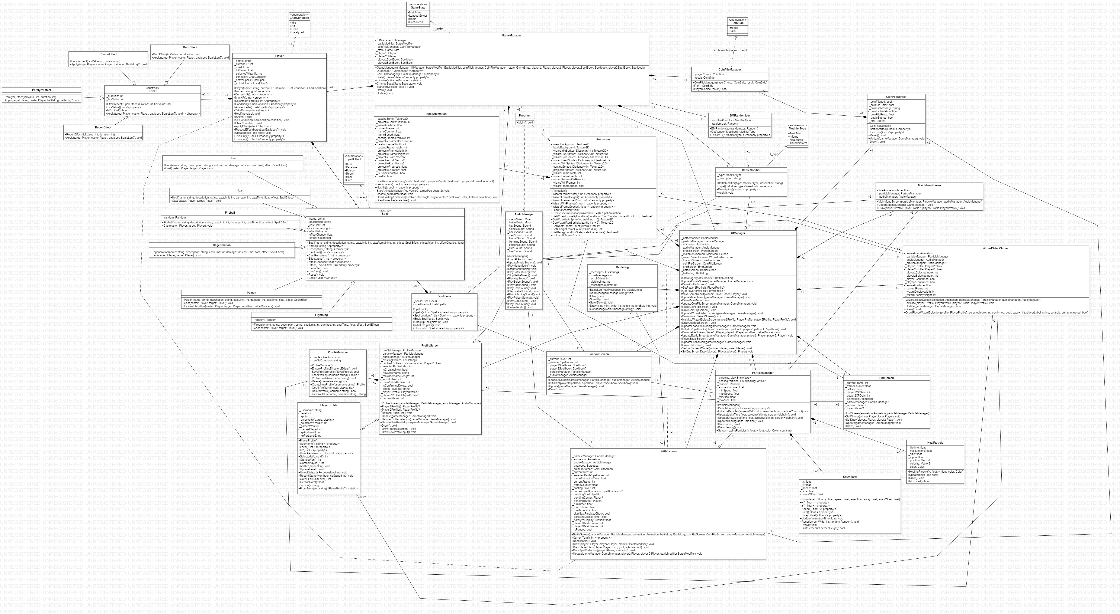

Sequence Diagram
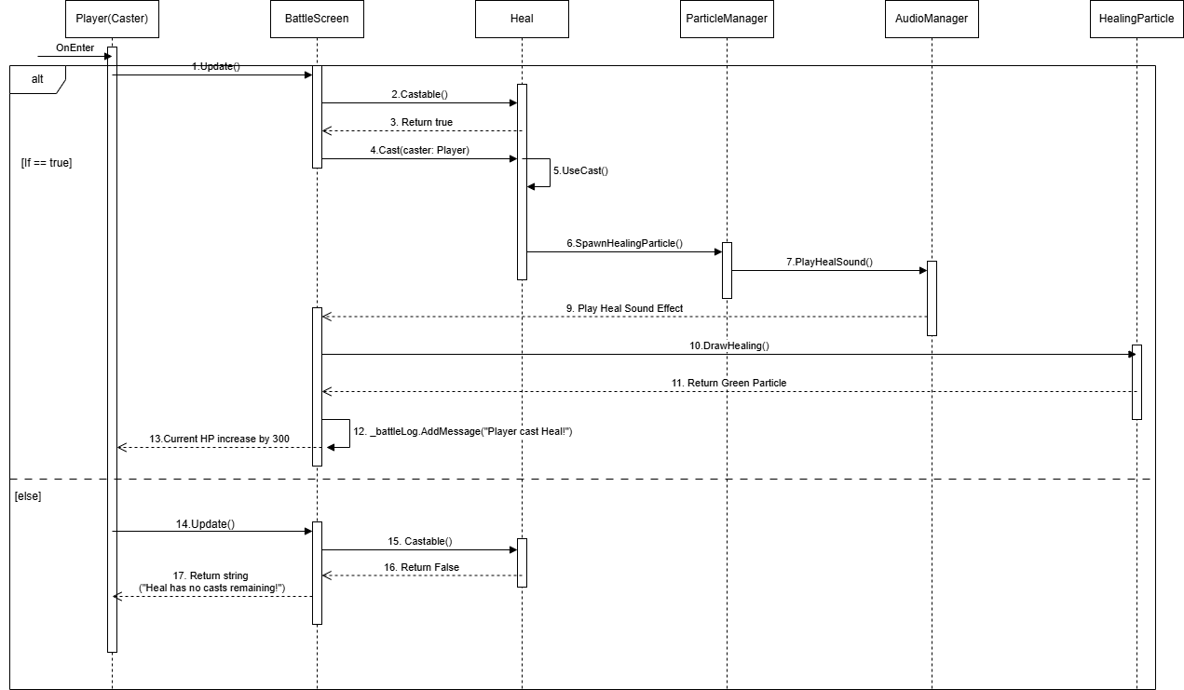

Lesson Learned
While developing Grimoire of the Ancients, I gained experience on how to handle big program such as organize the program and make the program maintainable. I learned how to implement object-oriented programming concepts such as Encapsulation, Abstraction, Inheritance and Polymorphism to a bigger scale. It helped me understand how these concepts support clean, flexible and efficient class or object collaboration in bigger program.

One of the major lessons that I’ve learned was the importance of planning when it comes to developing a program. With object-oriented principles that I’ve learned, I was able to break big problems that often occurs while dealing with big programs into smaller pieces. By doing that, debugging was easier and doesn’t need to worry about adding more features will break and create ripple effects on the program.

I encountered challenges such as saving player data and handling files, encouraging me to learn about JSON serialization to save the player’s profile. User Interface plays a big role in this program. I realized that the program felt incomplete without any User Interfaces. I learned how to implement UI such as background, animation, particle and sound effects.

Overall, I learned that developing program is an iterative process. Debugging, logic balancing and code organizing took some patience and persistence. But every time I did it, I found another better solution on how to improve the program in terms of game mechanics and game UI.

